AWS Certified AI Practitioner (AIF-C01)

There are 2 websites used for most of this class.
- AWS SkillBuilder – https://skillbuilder.aws
Useful free and subscribable site for self web-based trainings and exam preparations.
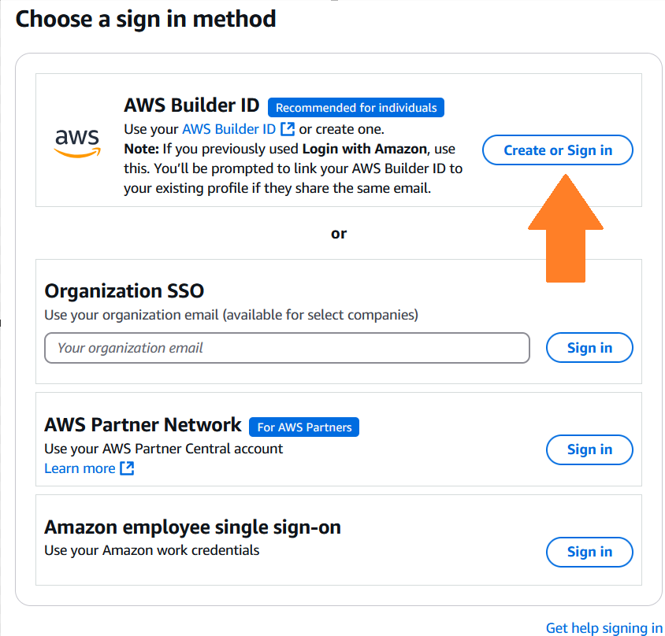

If you do not have a SkillBuilder account:
- Create an AWS Builder Labs account by using your Amazon Retail account/login.
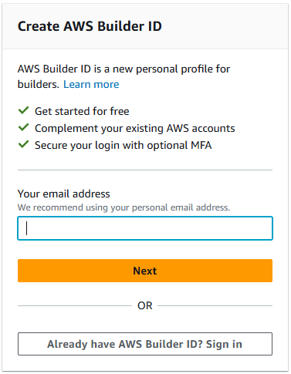
If you have a SkillBuilder account:
Verify access to lab guides and lab environments.


- AWS BuilderLabs (Student URL) for Generative AI Essentials on AWS – Lab Access
Go to: 🡪 Sign In with your AWS Builder ID
https://us-east-1.student.classrooms.aws.training/class/w3ky52TSHhW7LePKawAKbo
OR USE THIS
https://classrooms.aws.training

Access this Student Builderlab URL directly:
Labs available from 6 July – 9 Aug 2026

Student and Lab Guides (Student URL for Lab access and eBook redemption)
https://aws.vitalsource.com -> Create an Account to redeem your student eBook.
Vitalsource Bookshelf application download for offline reading:
https://support.vitalsource.com/hc/en-us/p/download
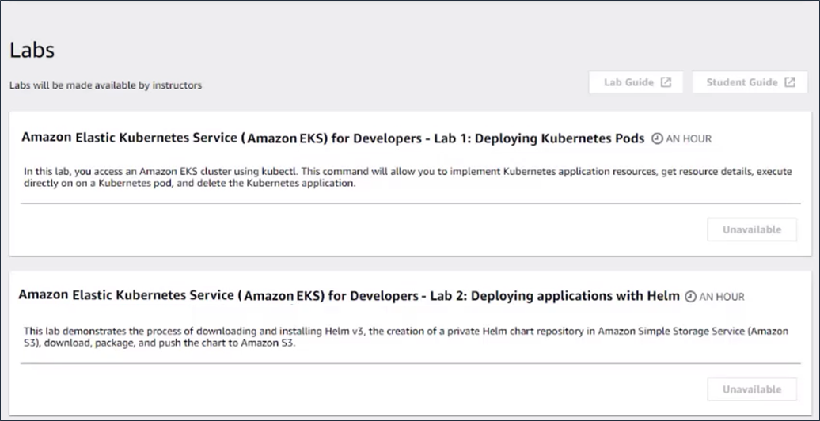

(Allowed to install on 2 PCs and 2 tablets)

AWS Certified AI Practitioner learning plan
https://skillbuilder.aws/exam-prep/ai-practitioner
 | Course | Time (hours)
CPE | AWS Cloud Practitioner Essentials | 3
1 | Fundamentals of Machine Learning and Artificial Intelligence  - GenAI Essentials Mod 1 | 1
2 | Exploring Artificial Intelligence Use Cases and Applications  - GenAI Essentials Mod 2 | 1
3 | Responsible Artificial Intelligence Practices  - GenAI Essentials Mod 4 | 1
4 | Developing Machine Learning Solutions  - GenAI Essentials Mod 6 & 7 | 1
5 | Developing Generative Artificial Intelligence Solutions  - GenAI Essentials Mod 6 & 7 | 1
6 | Essentials of Prompt Engineering  - GenAI Essentials Mod 3 | 1
7 | Optimizing Foundation Models  - GenAI Essentials Mod 3 & 6 | 1
8 | Security, Compliance, and Governance for AI Solutions  - GenAI Essentials Mod 4 & 5 | 1
9 | Generative AI for Executives | 0.5
10 | Amazon Q Business Getting Started | 0.5
11 | Amazon Bedrock Getting Started  -GenAI Essentials Mod 3 | 1
 | Exam Prep Standard Course: AWS Certified AI Practitioner | 2
 | Assessment | 1

Module # | COURSE CONTENT MAPPING  AWS Student eBook Courseware – Vitalsource Bookshelf | Skillbuilder Modules – PDF documents
CPE | AWS Cloud Practitioner Essentials
1 | Introducing Generative AI | Mod 1 Fundamentals of Machine Learning and Artificial Intelligence
2 | Exploring Generative AI Use Cases | Mod 2 Exploring Artificial Intelligence Use Cases and Applications
3 | Essentials of Prompt Engineering | Mod 6 Essentials of Prompt Engineering  Mod 7 Optimizing Foundation Models  Mod 11 Amazon Bedrock Getting Started
4 | Responsible AI Principles and Considerations | Mod 3 Responsible Artificial Intelligence Practices  Mod 8 Security, Compliance, and Governance for AI Solutions
5 | Security and Compliance for Generative AI Solution | Mod 8 Security, Compliance, and Governance for AI Solutions
6 | Implementing Generative AI Projects | Mod 4 Developing Machine Learning Solutions  Mod 5 Developing Generative Artificial Intelligence Solutions  Mod 7 Optimizing Foundation Models
7 | Integrating Generative AI into the Development Lifecycle | Mod 4 Developing Machine Learning Solutions  Mod 5 Developing Generative Artificial Intelligence Solutions
 |  | Mod 9 Generative AI for Executives
 |  | Mod 10 Amazon Q Business Getting Started
 |  | Exam Prep Standard Course: AWS Certified AI Practitioner
 |  | Assessment

APPENDIX - Lab references
Business Use Cases for Module 7 Optimizing Foundation Models Questions.
7. Optimizing Foundation Models with Retrieval Augmented Generation
Business Case 1
Introduction: AnyCompany, a telecom company
AnyCompany is a telecommunications provider offering phone and internet services.
Typically, customers experiencing issues contact AnyCompany's support center by phone, a process that is both costly and inefficient.
To streamline support, AnyCompany is shifting toward online solutions, initially creating an FAQ section on their website to address common problems. Despite this, the volume of online support tickets remains high. To further reduce the workload on their staff and enhance customer service efficiency, AnyCompany is exploring the potential of generative artificial intelligence (AI) to develop a chatbot. The chatbot would be capable of guiding customers, answering common issues, and performing certain tasks autonomously such as ordering a new phone, upgrading the phone plan to get more 5G data, and so on.
AnyCompany has a target of decreasing the number of online tickets by 70 percent after putting the chatbot into production. The company will also monitor the customer satisfaction score by providing a survey to their customers after solving their issues. With the addition of the chatbot, the company wishes to reach a satisfaction score of at least 4 out of 5.
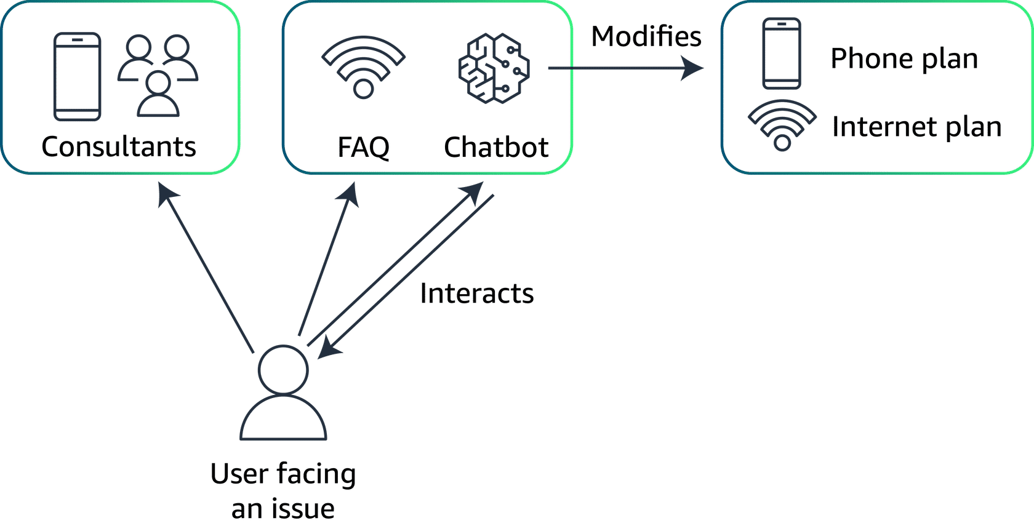

Look further into the solution
To build the chatbot, AnyCompany needs to choose a foundation model (FM). The model will need capabilities in natural language processing (NLP) and understanding, in addition to an integration with AnyCompany's backend system for automation.
AnyCompany needs to choose a large language model (LLM) because these FMs have the ability to understand and process natural language. LLMs are trained over a large amount of public data, which is great for general language understanding. However, this is not optimal to answer specific customer requests about AnyCompany's services. Therefore, AnyCompany needs a way to incorporate data and a knowledge base coming from AnyCompany to improve the accuracy of the chatbot's answers by providing it with more context.
This additional data might come from chat logs, previously handled support tickets, or even support call recordings. The data needs to be collected, anonymized, and cleansed to be incorporated in a knowledge base that can, in turn, be used by the chatbot.
Finally, because AnyCompany is willing to have the chatbot handle some tasks autonomously, the chatbot needs to be able to launch additional functions that can modify parameters in customers' accounts.

Business Case 2
7. Optimizing Foundation Models with Fine-Tuning
AnyCompany: A fashion retailer
AnyCompany, a trendy online fashion retailer, faces challenges with high cart abandonment rates and low repeat purchases. Customers often feel overwhelmed by the vast options and find it difficult to determine which products suit their personal style and needs.
AnyCompany aims to personalize the shopping experience more effectively, increasing user engagement, reducing cart abandonment, and boosting repeat purchases.
AnyCompany is willing to use the power of generative AI to achieve these goals. Specifically, they will monitor the following metrics:
- Conversion rate: Increase in successful purchases for each site visit
- Average order value: Increase in the dollar amount spent for each transaction
- Customer retention rate: Increase in the percentage of returning customers

The solution
AnyCompany will use an LLM that will have several functions. It will generate dynamic product descriptions, offer personalized shopping advice, and improve automated interactions. The solution will include the following:
- Utilization of specific datasets: Fine-tuning on transactional data, customer feedback, and user interaction data (likes, clicks, past purchases).
- Integration with recommendation engine: The AI model will adapt product displays and promotions to fit individual customer profiles in real time.
- Continuous learning: Adjust the model periodically, based on new customer data and evolving fashion trends, optimizing recommendation accuracy without manual intervention.
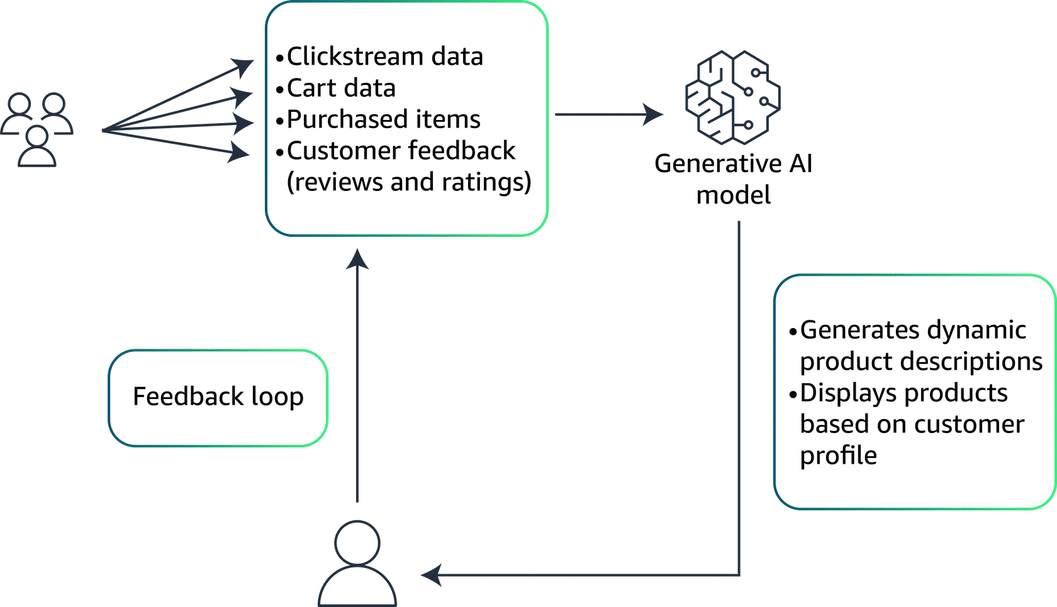

Exam Preparation Link
https://skillbuilder.aws/exam-prep/ai-practitioner

Certification Site
https://aws.amazon.com/certification/certified-ai-practitioner/?c=sec&sec=resources
Exam Guide https://d1.awsstatic.com/onedam/marketing-channels/website/aws/en_US/certification/approved/pdfs/docs-ai-practitioner/AWS-Certified-AI-Practitioner_Exam-Guide.pdf

AWS PARTYROCK
If you have the time to explore, https://partyrock.aws/home is a great site to develop your GenAI apps

Evaluation Link

CSAT Survey Link: https://au1.qualtrics.com/jfe/form/SV_cAAOvXJ4f0ffSLj?atpclassid=0a1cb34e-f8e8-43b1-b2be-99a92a48c51a&Q_Language=EN

USEFUL LINKS
Amazon S3
https://docs.aws.amazon.com/AmazonS3/latest/userguide/storage-class-intro.html
AWS Global Infrastructure: https://aws.amazon.com/about-aws/global-infrastructure/
IAM
Become an IAM Policy Master in 60 Minutes or Less https://youtu.be/YQsK4MtsELU?si=mj_YMSWYSqAdxCwS

Fundamentals of AI and ML
What Are Transformers in Artificial Intelligence?
What Is Overfitting?
What Are Large Language Models (LLMs)?
Easily Add Intelligence to Your Applications
Amazon SageMaker MLOps: From Idea to Production in Six Steps

Fundamentals of Gen AI
Selecting the Right Foundation Model for Your Startup
Generative Adversarial Networks Applications and its Benefits
The Complete Guide to Generative AI Architecture
PartyRock.aws
Monitoring Generative AI Applications Using Amazon Bedrock and Amazon CloudWatch Integration
AWS Cloud Adoption Framework for Artificial Intelligence, Machine Learning, and Generative AI
What Is a GAN?

Applications of Foundation Models
What Are Foundation Models?
Inference Parameters
Knowledge Bases for Amazon Bedrock
Agents for Amazon Bedrock
Amazon OpenSearch Service’s Vector Database Capabilities Explained
The Role of Vector Datastores in Generative AI Applications
Vector Engine for Amazon OpenSearch Serverless
What Is Prompt Engineering?
Metric: bleu
Metric: rouge
Domain-Adaptation Fine-Tuning of Foundation Models in Amazon SageMaker JumpStart on Financial Data

Security, Compliance and Governance for AI Solutions
Shared Responsibility Model
Securing Generative AI: Applying Relevant Security Controls
AWS Cloud Adoption Framework for Artificial Intelligence, Machine Learning, and Generative AI
AWS Compliance
NIST AI Risk Management Framework
ISO 42001: A New Foundational Global Standard to Advance Responsible AI
Learn How to Assess the Risk of AI Systems
Data Governance in the Age of Generative AI
AWS Security Blog
Securing generative AI: An introduction to the Generative AI Security Scoping Matrix
https://aws.amazon.com/blogs/security/securing-generative-ai-an-introduction-to-the-generative-ai-security-scoping-matrix/

Responsible AI
Responsible AI in the Generative Era
Transform Responsible AI from Theory into Practice
Tools and Resources to Build AI Responsibly
What Is RLHF?
Responsible AI Best Practices: Promoting Responsible and Trustworthy AI Systems

Projector Tensorflow
https://projector.tensorflow.org/

AWS Calculator
https://calculator.aws

AWS Workshops - technical workshops using your own AWS accounts
https://workshops.aws/categories/AI%2FML

Projector Tensorflow
https://projector.tensorflow.org/

AWS Services Cheatsheet (ML/AI services)
Service | Description

Amazon SageMaker | A fully-managed platform for data scientists and ML engineers to prepare data, build/train models, tune, deploy and monitor them at scale. Saves you from managing infrastructure and gives end-to-end ML workflow support.

Amazon Comprehend | A natural-language processing (NLP) service that uses ML to extract insights from unstructured text: entity recognition, sentiment, key phrases, language detection and topic modelling.

Amazon Rekognition | A computer vision service to analyse images and videos: detect objects, scenes, faces, text, inappropriate content, and enable custom vision pipelines.

Amazon Transcribe | Converts speech (audio/video) into text (speech-to-text) using deep learning; useful for transcription of calls, media, dialogues.

Amazon Polly | Text-to-speech service that converts written text into lifelike spoken audio in multiple languages/voices. Helps build voice-enabled applications.

Amazon Lex | Conversational interface service (voice/text) for chatbots and voice assistants, leveraging speech recognition + natural language understanding.

Amazon Translate | Neural machine translation service for localising applications/content quickly into multiple languages.

Amazon Forecast | Fully-managed time-series forecasting service using ML algorithms to predict metrics such as product demand, resource utilisation, finances.

Amazon Textract | Extracts text, handwriting and data from scanned documents and tables, going beyond simple OCR to structured document processing.

Amazon Bedrock | A generative-AI centric service: enables access to foundation models (FMs) from AWS and partners, supports private customisation and deployment of generative AI workflows.

Amazon Q | A more recent generative-AI assistant tool for developers: integrates with AWS workflows to support code completions, chat assistes for development tasks (work in AI space).

Amazon Augmented AI (A2I) | A human-in-the-loop service that allows you to build workflows for human review of ML predictions (e.g., for documents, images) to improve quality and compliance.
Amazon SageMaker Services
1. Data Preparation & Feature Engineering
Service | Description
SageMaker Data Wrangler | Provides a visual data preparation interface to import, clean, and transform data from multiple sources such as Amazon S3, Redshift, or Snowflake. It reduces data prep time from weeks to minutes and lets you visually engineer features without writing code.
SageMaker Feature Store | A centralized repository for storing and retrieving ML features in real time. It ensures feature consistency between training and inference, improving model accuracy and governance.
SageMaker Processing | Allows you to run data pre-processing, post-processing, and evaluation workloads on managed infrastructure. You can bring your own scripts or use pre-built containers to handle large-scale data pipelines.
2. Model Building & Experimentation
Service | Description
SageMaker Studio | A web-based IDE for machine learning, integrating notebooks, debugging, monitoring, and data wrangling in one place. It provides collaborative development tools for data scientists and engineers.
SageMaker Studio Notebooks | Fully managed Jupyter notebooks that automatically spin up compute resources and manage dependencies, making it easy to explore data and prototype models quickly.
SageMaker Autopilot | An AutoML service that automatically trains and tunes models for tabular data. It handles algorithm selection, hyperparameter tuning, and performance evaluation—while giving full transparency into the process.
SageMaker JumpStart | Offers pre-trained models, foundation models, and end-to-end ML solutions ready for fine-tuning or deployment. It accelerates development by reusing proven models from AWS and partners.
SageMaker Experiments | Tracks and organizes model training runs, hyperparameters, metrics, and artifacts. It helps teams compare results across experiments and identify the best-performing model.
3. Model Training & Optimization
Service | Description
SageMaker Training Jobs | Handles distributed or single-node model training on fully managed infrastructure. It scales automatically to the required compute, including GPU or CPU instances.
SageMaker Debugger | Monitors training progress and performance metrics in real time, detecting anomalies such as overfitting or vanishing gradients. It provides actionable insights during training.
SageMaker Hyperparameter Tuning (HPO) | Runs multiple training jobs with different hyperparameter combinations to find the optimal model configuration. Saves time and improves accuracy with Bayesian optimization.
SageMaker Distributed Training | Enables parallelized model or data training across multiple instances, significantly reducing training time for large datasets or deep learning models.

4. Deployment, Inference & Monitoring
Service | Description
SageMaker Endpoints | Provides fully managed, scalable endpoints for deploying trained models to serve real-time, batch, or asynchronous predictions. Handles autoscaling and versioning.
SageMaker Multi-Model Endpoints (MME) | Lets you deploy multiple models behind a single endpoint, dynamically loading models from Amazon S3 as needed. This optimizes cost and simplifies management.
SageMaker Serverless Inference | Deploys models without provisioning or managing compute instances. Automatically scales based on request load, ideal for low-traffic or bursty workloads.
SageMaker Model Monitor | Continuously observes data drift, bias, and performance degradation in deployed models. Helps maintain accuracy and compliance over time.
SageMaker Clarify | Detects bias in data and predictions and provides explainability reports for regulatory compliance and fairness analysis.
SageMaker Edge Manager | Manages and optimizes machine learning models running on edge devices, allowing fleet monitoring, over-the-air updates, and resource optimization.
5. Generative AI & Foundation Model Integration
Service | Description
SageMaker JumpStart (GenAI Edition) | Enables direct access to foundation models (FMs) from AWS and third-party providers like Anthropic, Stability AI, and Meta. Users can fine-tune or deploy models for custom GenAI use cases.
SageMaker Canvas | A no-code visual interface that empowers business analysts to generate predictions or run GenAI tasks without programming. Ideal for democratizing ML within organizations.
SageMaker Pipelines | A CI/CD pipeline service purpose-built for MLOps, automating each step of the ML lifecycle—data preparation, training, testing, and deployment.
SageMaker Model Registry | A central repository to register, version, and approve ML models before deployment. Integrates with CI/CD pipelines for production governance.
6. MLOps, Governance & Security
Service | Description
SageMaker Projects | Provides pre-built MLOps templates using AWS CodePipeline and CodeBuild to implement standardized workflows for model deployment and governance.
SageMaker Role & Policy Management (IAM) | Integrates with AWS IAM to control access to SageMaker resources, notebooks, and endpoints, ensuring security and compliance.
SageMaker Audit Trails (via CloudTrail) | Logs all user actions, API calls, and workflow executions for auditability and traceability within enterprise ML environments.

Day 1 Chat
Class materials share drive: https://tinyurl.com/awsaiprac0226

Vitalsource Online: https://online.vitalsource.com/
AWS Classroom: https://aws.amazon.com/training/classroom/

Attendance: https://www.myskillsfuture.gov.sg/api/take-attendance/RA621290

Skill Builder : https://skillbuilder.aws/

Exam guide: https://d1.awsstatic.com/training-and-certification/docs-ai-practitioner/AWS-Certified-AI-Practitioner_Exam-Guide.pdf

AWS Global infrastructure: https://aws.amazon.com/about-aws/global-infrastructure

- AWS Outpost On-prem AWS services and infrastructure : https://aws.amazon.com/outposts/
- AWS CloudFront (CDN - Content Delivery Network): https://aws.amazon.com/cloudfront/
- https://aws.amazon.com/cloudfront/features/
Edge location: A site that CloudFront uses to cache copies of your content for faster delivery to users at any location.

EC2
EC2 : https://aws.amazon.com/ec2/
Instance Types: https://aws.amazon.com/ec2/instance-types/
For finding the right instance types: https://aws.amazon.com/ec2/instance-explorer/
Amazon EC2 G4 Instances: https://aws.amazon.com/ec2/instance-types/g4/

EC2 On-Demand Pricing : https://aws.amazon.com/ec2/pricing/on-demand/

Lambda
https://aws.amazon.com/lambda/

Pricing
AWS Free tier : https://aws.amazon.com/free/
To know more about the pricing : https://aws.amazon.com/pricing/
For each AWS service, there are dedicated pricing page, such as for EC2: https://aws.amazon.com/ec2/pricing/

Pricing calculator : https://calculator.aws/

For more info about AWS budget : https://aws.amazon.com/aws-cost-management/aws-budgets/
Hands-on tutorials to Control AWS Costs: https://docs.aws.amazon.com/hands-on/latest/control-your-costs-free-tier-budgets/control-your-costs-free-tier-budgets.html?refid=ap_card

Other Services
AWS service - Amazon Managed Streaming for Apache Kafka : https://aws.amazon.com/msk/
Amazon Kinesis : https://aws.amazon.com/kinesis/
EFS FAQ : https://aws.amazon.com/efs/faq/

Day 2 Chat
Root account best practices - https://docs.aws.amazon.com/IAM/latest/UserGuide/root-user-best-practices.html
Tutorial for securing your account - https://docs.aws.amazon.com/hands-on/latest/setup-environment/setup-environment.html
Root user tasks https://docs.aws.amazon.com/IAM/latest/UserGuide/id_root-user.html#root-user-tasks

Reference ARN : https://docs.aws.amazon.com/IAM/latest/UserGuide/reference-arns.html
To get started, you can try out this policy generator : https://awspolicygen.s3.amazonaws.com/policygen.html

If you want to test or check how the policy that you create : https://policysim.aws.amazon.com/
Docs: https://docs.aws.amazon.com/IAM/latest/UserGuide/access_policies_testing-policies.html

AWS Certification Manager: https://aws.amazon.com/certificate-manager/

Services by Region: https://aws.amazon.com/about-aws/global-infrastructure/regional-product-services/
Amazon Bedrock Pricing: https://aws.amazon.com/bedrock/pricing/
Amazon Nova : https://aws.amazon.com/nova/pricing/

Day 3
https://docs.aws.amazon.com/bedrock/latest/userguide/inference-parameters.html
An example for customer reviews: https://aws.amazon.com/blogs/machine-learning/analyze-customer-reviews-using-amazon-bedrock/
https://docs.aws.amazon.com/bedrock/latest/userguide/prompt-engineering-guidelines.html
https://docs.aws.amazon.com/bedrock/latest/userguide/prompt-templates-and-examples.html

Day 4
Secret manager: https://docs.aws.amazon.com/secretsmanager/latest/userguide/intro.html
https://docs.aws.amazon.com/bedrock/latest/userguide/guardrails.html
https://docs.aws.amazon.com/bedrock/latest/userguide/guardrails-delete.html

Bedrock models - Which region etc:
https://docs.aws.amazon.com/bedrock/latest/userguide/models-regions.html

Supported Bedrock models: https://docs.aws.amazon.com/bedrock/latest/userguide/models-supported.html

Vector database
https://aws.amazon.com/what-is/vector-databases/
“How can AWS support your other vector database requirements?
Amazon Web Services (AWS) offers many additional services for your vector database requirements, especially if you need vector search for existing data in other places (Amazon Aurora, Amazon S3, Amazon MemoryDB):
- Amazon Aurora PostgreSQL-Compatible Edition and Amazon Relational Database Service (Amazon RDS) for PostgreSQL support the pgvector extension to store embeddings from machine learning (ML) models in your database and to perform efficient similarity searches.
- Amazon Neptune ML is a new capability of Neptune that uses Graph Neural Networks (GNNs), an ML technique purpose-built for graphs, to make easy, fast, and more accurate predictions using graph data.
- Vector search for Amazon MemoryDB supports storing millions of vectors, with single-digit millisecond query and update response times, and tens of thousands queries per second (QPS) at greater than 99% recall.
- Amazon DocumentDB (with MongoDB compatibility) supports vector search, a new capability that enables you to store, index, and search millions of vectors with millisecond response times. With vector search for Amazon DocumentDB, you can simply set up, operate, and scale databases for your ML applications. “

AWS Audit Manager
https://aws.amazon.com/audit-manager/
https://aws.amazon.com/audit-manager/faqs/
https://docs.aws.amazon.com/audit-manager/latest/userguide/audit-manager-availability-change.html
AWS Audit Manager will no longer be open to new customers starting April 30, 2026. If you would like to use Audit Manager, sign up prior to that date. Existing customers can continue to use the service as normal.

